
MINISTRY OF EDUCATION
P.O. Box 97, Rarotonga, Cook Islands

Government of the Cook Islands
Phone: (682) 29 - 357 Fax: (682) 28 - 357

POSITION DESCRIPTION

Position Title: | Manager – Human Resources
Division: | Corporate & Operational Services
Responsible To: | Assistant Secretary – Corporate & Operational Services
Responsible For: | 9 x FTE staff, 20 x PTE staff (teacher relievers)
Job Purpose: | To lead and manage the full spectrum of human resource services within the Ministry of Education, from workforce planning, recruitment, and on boarding to retention, performance, professional development, and release. The role ensures that all HR policies, systems, and processes support the Ministry’s strategic direction, including the implementation of the Education Masterplan. The Manager is responsible for leading a team of HR Officers, fostering a positive and compliant workplace culture, and ensuring that staffing, development, and welfare practices align with Cook Islands public service values and legislative requirements.
Job classification: | FTE
Date: | 31 March 2025

MINISTRY VISION:

Akamatutuanga i te au karape, kite, te tu tangata e te irinakianga o te iti tangata Kuki Airani kia rauka ia ratou i taangaanga i ta ratou au tareni ki roto i to ratou oraanga.

Building the skills, knowledge, attitudes, and values of Cook Islanders to put their capabilities to best use in all areas of their lives.

ORGANISATION CHART:

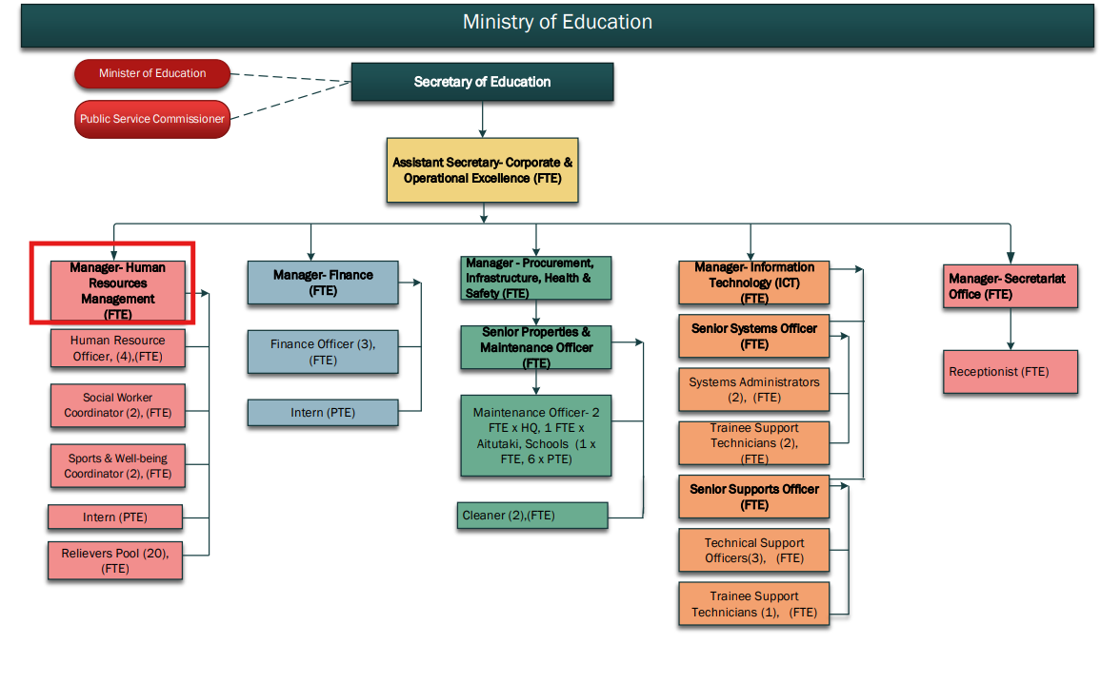

KEY RESULTS AREA:

K.R.A | Key Performance Indicators
1. HR Strategy and Policy Development  Develop, implement, and review HR policies and strategic plans aligned with the Ministry’s goals, legislation, and values. | - HR strategy reviewed annually and approved by leadership  - All policies updated regularly and aligned to legislation  - Staff informed and trained on major policy changes
2. Workforce Planning, Recruitment, and Onboarding  Lead workforce planning and oversee all recruitment and onboarding processes to ensure the Ministry attracts, selects, and integrates quality personnel. | - Annual workforce plan prepared and monitored  - 100% of vacancies advertised and recruited using transparent, approved processes  - Onboarding completed within two weeks of start
3. Retention, Succession, and Career Progression  Implement staff retention strategies and succession planning while promoting opportunities for internal advancement and long-term workforce sustainability. | - Annual retention and turnover report produced with analysis and recommendations  - Succession planning framework established for key roles  - Career pathway maps developed and communicated
4. HR Team Leadership and Management  Lead, supervise, and develop a team of four HR Officers to deliver effective HR services and meet Ministry-wide priorities. | - Annual performance appraisals completed for all HR team members  - Monthly team meetings held and documented  - Professional development plans in place for all HR staff
5. Professional Development and Capability Building  Coordinate learning and development programmes that build staff capability and align with Ministry priorities, including initiatives through the Teacher Development Centre. | - Annual PD plan developed in consultation with Assistant Secretaries  - At least 90% of staff complete one or more relevant PD activities annually  - Induction, refresher, and leadership development programmes implemented
6. Performance Management and Staff Appraisal  Oversee implementation of a consistent, fair, and constructive performance appraisal system to promote accountability and professional growth. | - Annual performance reviews completed for 100% of staff  - Underperformance addressed through structured improvement plans  - Annual workshops delivered to support managers with appraisals
7. Complaints, Disciplinary, and Staff Issues Management  Lead the management of complaints, grievances, and disciplinary processes in accordance with policy, ensuring fairness, confidentiality, and legal compliance. | - All formal complaints acknowledged within 5 working days  - Investigations conducted and resolved within 20 working days  - All disciplinary processes documented and legally compliant
8. Employee Welfare, Wellbeing and Support  Coordinate wellbeing and support initiatives that promote a healthy, safe, and supportive working environment, including access to staff care services. | - Staff wellbeing initiatives implemented annually and evaluated  - Staff satisfaction survey conducted and actioned  - Support and referral services in place and accessible to all staff
9. Exit and Offboarding Management  Oversee respectful and compliant offboarding processes for resignations, retirements, and terminations, ensuring smooth transitions and useful feedback. | - 100% of voluntary leavers offered exit interviews  - Offboarding checklist completed for all staff exits  - Exit data reported quarterly and used to improve HR practices
10. HR Data, Systems and Reporting  Manage HR information systems and ensure timely and accurate reporting for internal management, compliance, and audit purposes. | - Monthly and quarterly HR reports submitted  - Compliance and audit documentation maintained and accessible

WORK COMPLEXITY:

Indicate Most challenging duties typically undertaken:
1 | Managing HR functions across a diverse workforce, ensuring compliance with national labor laws and policies.
2 | Balancing the need for staff development and career progression with operational and budgetary constraints.
3 | Developing and implementing policies that address the unique needs of the educational workforce.
4 | Addressing employee relations issues while fostering a positive and productive workplace culture.

AUTHORITY:
Authority levels expressed in terms of routine expenditure, granting loans, and recruiting and dismissing staff. (Explain the authority if any)

Financial | Managing HR budgets for recruitment, training, and welfare programs in collaboration with Assistant Secretary- COE
Staff | Supervision of HR staff and coordination of employee welfare programs, in collaboration with Assistant Secretary- COE
Contractual | Authority to engage with external HR service providers and consultants, in collaboration with Assistant Secretary- COE

FUNCTIONAL RELATIONSHIPS:
The requirement for human relations skills in dealing with other personnel and external contacts. (List the external and internal types of functional relationships)

Internal | Nature of Contact | External | Nature of Contact
Assistant Secretary | Reporting on HR initiatives, staff issues, and policy development. | Government HR and Labour Departments | Ensuring compliance with national labour regulations and HR best practices.
Other Ministry Divisions | Coordinating HR services and policies across all divisions. | External HR Consultants | Engaging with consultants for specialized HR support.

QUALIFICATION:

Level of education required to perform the functions required of the position. This combines formal and informal levels of training and education.

Essential: (least qualification to be competent) | Desirable: (specific qualification for job)
Bachelor’s degree in Human Resource Management, Business Administration, or related field. | Master’s degree in Human Resources or Organizational Development.

Knowledge / Experience
The length of practical experience and nature of specialist or managerial familiarity required. This experience is in addition to formal education.

Essential: (least number of years to be competent) | Desirable: (target number of years you are looking for)
Minimum of 5 years of experience in HR management. | 7+ years of experience with a focus on HR policy development and employee relations.

Key Skills /Attribute / Behaviours

Level of ability required for the job | Description
Expert | HR Policy Development – Able to design, implement, and review HR policies that are legally compliant, strategically aligned, and responsive to the unique needs of the education sector.  Recruitment – Skilled in leading transparent, fair, and effective recruitment processes that secure high-quality staff across diverse roles.  Employee Relations – Proficient in managing staff relations, fostering a positive workplace culture, and resolving complex employment matters in line with legislation and best practice.
Advanced | Staff Development – Capable of designing and coordinating professional development pathways that build staff capacity, support career progression, and align with organisational goals.  Conflict Resolution – Skilled in facilitating resolution of workplace disputes through mediation, negotiation, and application of fair disciplinary procedures.
Working: | Cross-Departmental Collaboration – Able to work effectively with other divisions, schools, and government agencies to deliver integrated HR solutions.  Budget Management – Competent in managing HR-related budgets, ensuring efficient allocation of resources for recruitment, training, and welfare programmes
Awareness | Current Trends in HR Practices – Maintains up-to-date knowledge of emerging HR trends, labour law changes, and workforce management innovations to inform Ministry HR strategy

Approved:

Head of Ministry – Secretary of Education Date

Employee Date

