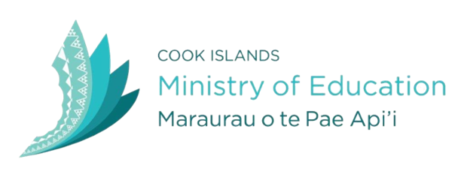
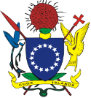

2021 TE REINGA AKATAUNGA’ANGA
THE COOK ISLANDS TERTIARY STUDY SUPPORT PROGRAMME

The Government of the Cook Islands, through the Ministry of Education, is now seeking “Expressions of Interest” for Scholarship awards from suitably qualified Cook Islanders and Permanent Residents residing in the Cook Islands.

Domestic Scholarships:
- Full Scholarship – This type of scholarship is intended for school leavers including students who are already studying part time and wish to fast track their degree by studying full time.

- Study Grant – This grant is suitable for those in the workforce who have a good study record and can make a reasonable time commitment to further study.

Applicants who are already studying must have successfully completed at least 4 courses with at least a “B” grade average at an approved tertiary institute and the course of study should be pursued here in the Cook Islands even if the provider is located off-shore.

International Scholarships:
- Study Starter Pack – This support opportunity is a one off grant for school leavers and mature applicants wishing to travel to New Zealand for their first year of study.

- Full Scholarship (from second year of study onwards) – This type of scholarship is for students meeting the criteria of the Study Starter Pack and those studying privately. Students should submit application by the due date even if they haven’t received their semester 2 results.

Applicant selection will be based on meeting the scholarship eligibility criteria, primarily that of academic merit (i.e. have completed a minimum equivalent of one full academic year with at least a “B” grade average)

Application forms and further information are available from the Ministry of Education headquarters in Nikao, Rarotonga, or online at www.education.gov.ck. For further details please contact Scholarships Advisor, Anna Roi, on Ph: 29357 ext 5042 or email scholarships@education.gov.ck.

For further information about the programme and its requirements, contact Anna Roi on ph. 29357 ext 5042 or email scholarships@education.gov.ck or visit our website on www.education.gov.ck.

Application forms must be received no later than 12noon Friday 20th November 2020.

