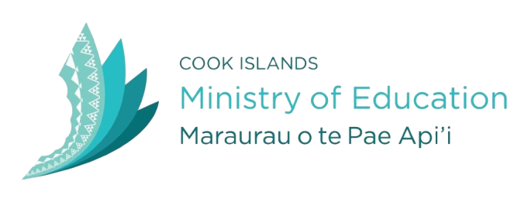

COOK ISLANDS GOVERNMENT SCHOLARHIP
(TE REINGA AKATAUNGA’ANGA)

INTERNATIONAL OPTIONS

1. STUDY STARTER PACKS
What it covers?
An initial one off grant to students wishing to travel overseas to study. The starter pack is available to first year students only. This includes mature students commencing any level of study.

The grant provides
Flights: $1100 maximum
Establishment costs: $3000

Who is Eligible?
All Cook Islanders domiciled in the Cook Islands including PRs or dependents thereof.
- A school leaver who has completed at least the last 2 years of secondary schooling in the Cook Islands
or
- A mature student who has lived 5 of the last 10 years in the Cook Islands including at least the last two years consecutively

Liability:
The starter pack is the risk carried by government. Once the student has received a starter pack the remaining costs for their first year of study can be applied for through the student loan and study link system.
Scholarships then become available at different levels from second year onwards based on achievement in the first year.
This provides a system with relatively small outlay by government initially and requires achievement by the student before commitment of government to further funding.

Criteria:
These starter packs (up to 20) are intended to give opportunity for Cook Islanders to study across a wide range of programme areas and levels. The first 10 starter packs to be distributed as follows:

- Top two Year 13 results (any course)
- Top 4 linkages to Labour Market (any programme)
- Top 2 TVET programmes (certificate or diploma programmes)
- Top entrepreneurial/enterprise applicant
- Top Pa Enua (either there or student on OIAG at other school)

The remaining packs (up to 10) on the basis of academic merit (in relation to the course), link to labour market/NSDP and demonstrated knowledge/skill in area of study.

2. FULL SCHOLARSHIP (FROM SECOND YEAR OF STUDY)
What it covers?
Return flights annually.
Students continue to study with student loan for tuition and any eligible student allowance and living cost.
Scholarship tops up living cost to combined maximum per $830 per fortnight
On return the entire loan (including first year) is paid off pro-rata by scholarship.

Who is Eligible?
All Cook Islanders domiciled in the Cook Islands including PRs or dependents thereof.
- A school leaver who has completed at least the last 2 years of secondary schooling in the Cook Islands and gone straight to study.
or
- A mature student who has lived 5 of the last 10 years in the Cook Islands including at least the last two years consecutively before going to study.

Liability:
Failure to successfully complete programme or failure to return – loan remains a liability to the student.

Criteria:
Top 10 applicants with required evidence of success in first year of study.
Awards will consider
- academic achievement in first year of study
- links to labour market and NSDP

3. COOK ISLANDS INTERNATIONAL STUDENT SUCCESS GRANT
What:
Reimbursement of up to 50 % tuition fees on successful completion of semester (based on results).
Programmes of study in New Zealand, Australia or Pacific region

Who is Eligible?
All Cook Islanders including PR holders and dependents thereof domiciled for at least the 5 years prior to application

Liability:
None

Criteria:
Must demonstrate intention to return to Cook Islands eg enduring relationship through parents

4. RETURNING COOK ISLANDER GRANT
What it covers?
Reimbursement of tuition part of student loan on per annum basis (to a maximum of $5k per annum)

Who is Eligible?
Cook Islander who has completed a tertiary qualification in New Zealand and returns home.
Was not domiciled in Cook Islands immediately prior to study but demonstrates enduring relationship e.g. parents, significant periods of stay

Liability:
None – qualification has been completed

Criteria:
Returns and engages in fulltime employment/business development for at least 1 year before applying.

