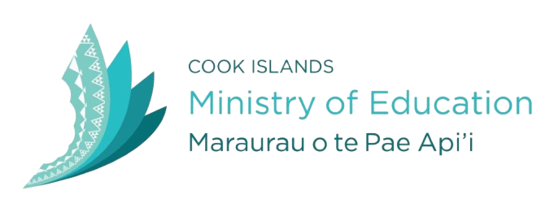

2017 NEW ZEALAND COMMONWEALTH SCHOLARSHIPS
The Government of the Cook Islands is seeking “Expressions of interest” for Scholarship awards from suitably qualified Cook Islands men and women to study at a New Zealand academic institution commencing in February 2017. Scholarships are funded by the New Zealand Aid Programme and managed through the New Zealand Ministry of Foreign Affairs and Trade and are for PhD or Masters level study only.

The scholarships are available to those working in the public and private sectors, in the Cook Islands. Applicants who have lived in the Cook Islands 2 years prior to applying are also eligible to apply. There are 2 awards available for this scheme and these will be offered equitably to 1 female and 1 male candidate.

For further information and application forms, contact Anna Roi on ph 29357 ext. 245 or email aroi@education.gov.ck. Application forms can also be accessed on the Ministry’s website: www.education.gov.ck. Application forms must be received no later than 12pm Friday 22nd April 2016.

